# HTML injection reflected

# HTML injection reflected

PHPSESSID=gq8v9ve80n1boec9v265isdtnv; security_level=0

# Hello

:

# Hello

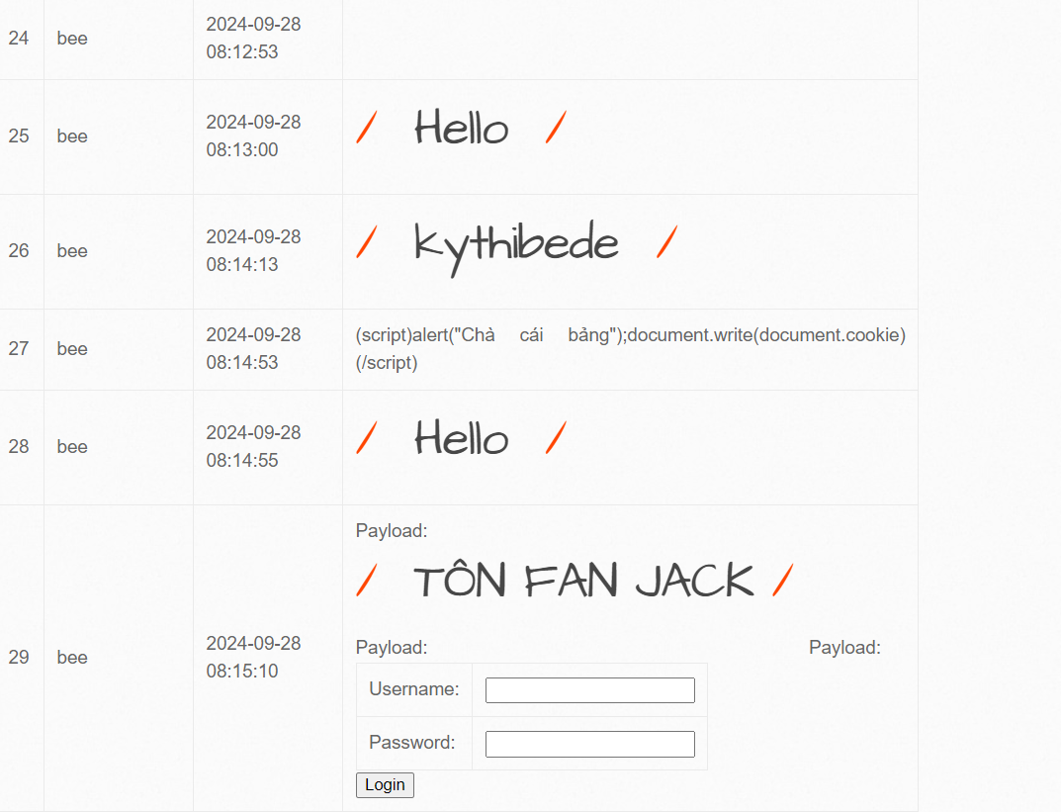

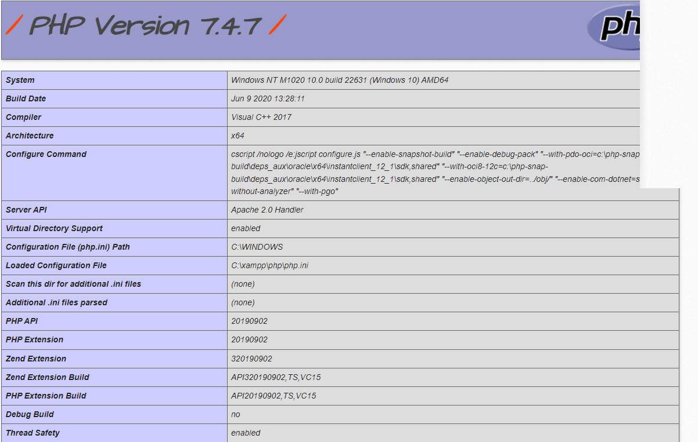

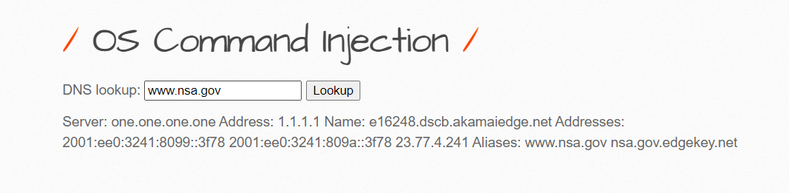

## HTML Injection - Reflected (GET)

## HTML Injection - Reflected (GET)